# Lab Manual 10

# Latches

## Objectives:

To learn and understand the working of Latches

## Sequential Circuits

Sequential circuits have the property that the output depends not only on the present input but also on the past sequence of inputs. In effect, these circuits must be able to “remember” something about the past history of the inputs in order to produce the present output. Latches and flip-flops are commonly used memory devices in sequential circuits. Basically, latches and flip-flops are memory devices which can assume one of two stable output states and which have one or more inputs that can cause the output state to change.

Each of the **flip-flops** has a clock input, and the flip-flops can only change state in response to a clock pulse. A memory element that has no clock input is often called a **latch.**

## Problems / Assignments

|  |  |
| --- | --- |
| Problem 1 |  |

Implement an $\overline{S }$ $\overline{R}$ latch with control input as follows:

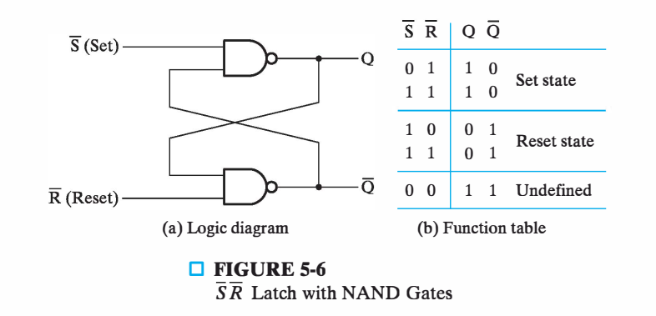

|  |  |
| --- | --- |
| Problem 2 |  |

Implement an SR latch with control input as follows:

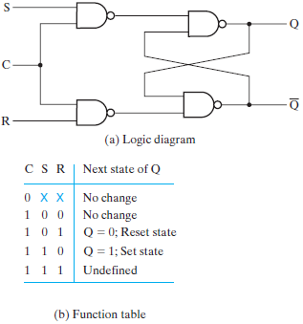

|  |  |
| --- | --- |
| Problem 3 |  |

Implement following D-Latch:

